**Chapter 10 pages 259-268**

**TODAY YOU WILL BE ABLE TO…**

* Describe the idea of probability
* Describe chance behavior with a probability model
* Apply basic rules of probability

**THE IDEA OF PROBABILITY**

***Example 1:*** If you toss a coin, the result cannot be predicted in advance because the results will **vary** with repeated coin tosses. Variability can be due to different people tossing the coin and/or different circumstances: how high or hard was the coin tossed, at what angle was it tossed, what side did the person start on, was the coin’s trajectory stopped or altered by another force or object? However, a **pattern** will emerge after many repetitions.

**Chance behavior is unpredictable in the short run but has a regular and predictable pattern in the long run.**

***Example 2:*** Simple Random Samples (SRS)

* Eliminate bias when choosing a sample
* Can still be inaccurate with respect to the population because of variability in the results

Results from an SRS cannot be trusted if the variation when you take repeat samples from the population is too great.

**Randomness and Probability**

We call a phenomenon **random** if individual outcomes are uncertain (e.g., whose name I will draw to answer the next question) but there is nonetheless a regular distribution of outcomes in a large number of repetitions (e.g., by the end of the semester, everyone will have been called roughly the same number of times).

**PROBABILITY MODELS**

A probability model describes the possible outcomes of an event and the probabilities associated with each outcome.

The **sample space S** of a random phenomenon is the set of all possible outcomes.

An **event** is an outcome or a set of outcomes of a random phenomenon. That is, an event is a subset of the sample space.

A **probability model** is a mathematical description of a random phenomenon consisting of two parts:

1. A sample space S
2. A way of assigning probabilities to events.

**Practice with Sample Spaces**

***Example 3:*** Choose a student at random from the class. Describe a sample space S for each of the following.

1. Does the student live on campus or off campus?
2. What is the student’s age in years?
3. How much money in coins (not bills) is the student carrying?
4. What is the student’s letter grade at the end of the semester?

***Example 4:*** Six-sided, fair dice.

|  |  |
| --- | --- |
| **What is on the die** | **Sample Space** |
| Face value on one standard die (1 to 6 dots) |  |
| Face value of die with 1, -2, 3, -4, 5, -6 |  |
| Face value of die with 2X, 2X, 3X, 3X, X, and X ***Note:*** Sides are indistinguishable except by the values |  |
| Face value on two standard die (2 to 12 dots) ***Note:*** Die are distinguishable by color |  |

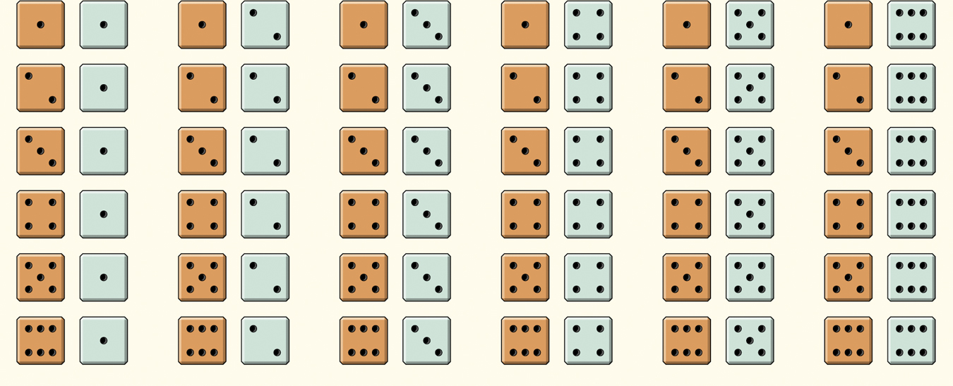

**Practice with Probability Models**

***Example 5:*** Six-sided, fair dice. Since the dice are fair, each outcome is equally likely.

|  |  |  |  |  |  |  |
| --- | --- | --- | --- | --- | --- | --- |
| **Sample Space** | 1 | 2 | 3 | 4 | 5 | 6 |
| **Probability** |  |  |  |  |  |  |
| **Sample Space** | 1 | -2 | 3 | -4 | 5 | -6 |
| **Probability** |  |  |  |  |  |  |
| **Sample Space** | X | | 2X | | 3X | |
| **Probability** |  | |  | |  | |

**PROBABILITY RULES**

The probability rules follow from the idea of probability as “the long-run proportion of repetitions on which an event occurs.”

1. Any probability is a number between 0 and 1.

***Example 6:*** Probability is a measure of how likely an event is to occur. Match one of the probabilities that follow with each statement of likelihood given. Some probabilities have no matching statement.

|  |  |  |  |
| --- | --- | --- | --- |
|  | 0 |  | 1. This event is certain. It will occur on every trial. 2. This event will occur slightly less often than not. 3. This event will occur as often as not. 4. This event is impossible. It will never occur. 5. This event is unlikely but will occur once in a while in a long sequence of trials. |
|  | 0.01 |  |
|  | 0.45 |  |
|  | 0.50 |  |
|  | 0.55 |  |
|  | 0.99 |  |
|  | 1 |  |

1. All possible outcomes together must have probability 1.

Because some outcome must occur at every trial, the sum of probabilities for all possible outcomes must be exactly 1.

1. If two or more events have no outcomes in common, they are called **disjoint** events, and the probability that one or another occurs is the sum of their individual probabilities.
2. The probability that an event does not occur is 1 minus the probability that the event does occur.

***Example 7:*** Languages in Canada

Canada has two official languages: French and English. Many people in Canada are bilingual, however, they likely consider only one language their mother tongue. Select a Canadian at random and ask “What is your mother tongue?” The distribution of responses, combining many separate languages from the province of Quebec, follows:

|  |  |  |  |  |
| --- | --- | --- | --- | --- |
| Language | English | French | Italian | Other |
| Probability | 0.08 | 0.80 | 0.02 |  |

1. Fill in the probability for the “Other” category. (Rules 1 and 2)
2. What is the probability that a Canadian’s mother tongue is not English? (Rule 3 or 4)
3. What is the probability that a Canadian’s mother tongue is a language other than English or French? (Rule 3 and 4)

|  |
| --- |
| **Summary of Rules with Mathematical Shorthand**   1. The probability P(A) of any event A satisfies 0 ≤ P(A) ≤ 1. 2. If S is the sample space in the probability model, the P(S)=1 3. Two events A and B are disjoint if they have no outcomes in common and so can never occur together. If A and B are disjoint, P(A or B) = P(A) + P(B), which is known as the **addition rule for disjoint events**. 4. For any event A, P(A does not occur) = 1 – P(A). |

***Example 8:*** Although the rules of probability are just basic facts about percentages or proportions, we need to be able to use the language of events and their probabilities.

Choose an American adult at random. Define the three events:

A = the person chosen has no children*

B = the person chosen has one child*

C = the person chosen has two children*

*Children are counted if born and if under the age of 18 – this reflects the Census Bureau and IRS definition and in no way makes a statement about the value of an unborn life

The probabilities for each event are…P(A)=0.55, P(B)=0.19, and P(C)=0.16

1. Explain why events A, B, and C are disjoint.
2. Say in plain language what the event “A or B or C” is. What is P(A or B or C)?
3. If D was the event that the person chosen has three or more children, what is P(D)?

***Example 9:*** Distance-learning courses are rapidly gaining popularity among college students. Randomly select an undergraduate student who is taking distance-learning courses for credit and record the student’s age. Here is the probability model:

|  |  |  |  |  |
| --- | --- | --- | --- | --- |
| Age group (yr): | 18 to 23 | 24 to 29 | 30 to 39 | 40 or over |
| Probability: | 0.57 | 0.17 | 0.14 | 0.12 |

1. Show that this is a legitimate probability model.
2. Find the probability that the chosen student is not in the traditional college age group (18 to 23 years).

**Chapter 10 pages 268-278**

**TODAY YOU WILL BE ABLE TO…**

* Describe finite and discrete probability models
* Describe continuous probability models
* Define random variables

**FINITE AND DISCRETE PROBABILITY MODELS**

The models we have worked with so far are **finite** and **discrete** probability models. We assigned probabilities to every individual outcome because the number of outcomes for each model was finite, i.e., fixed and limited.

**CONTINUOUS PROBABILITY MODELS**

A **continuous probability model** assigns probabilities as areas under a density curve. The area under the curve and above any range of values is the probability of an outcome in that range.

***Example 10:*** Suppose we want to choose a number at random between 0 and 1, allowing *any* number between 0 and 1 as the outcome. We cannot assign probabilities to each individual value because there is an infinite interval of possible values.

Find the probability of getting a random number that is less than or equal to 0.5 OR greater than 0.8.

Each value is equally likely so this is a uniform distribution.

*P*(X ≤ 0.5 or X > 0.8) = *P*(X ≤ _______) + *P*(X > _______) = _______ + _______ = _______

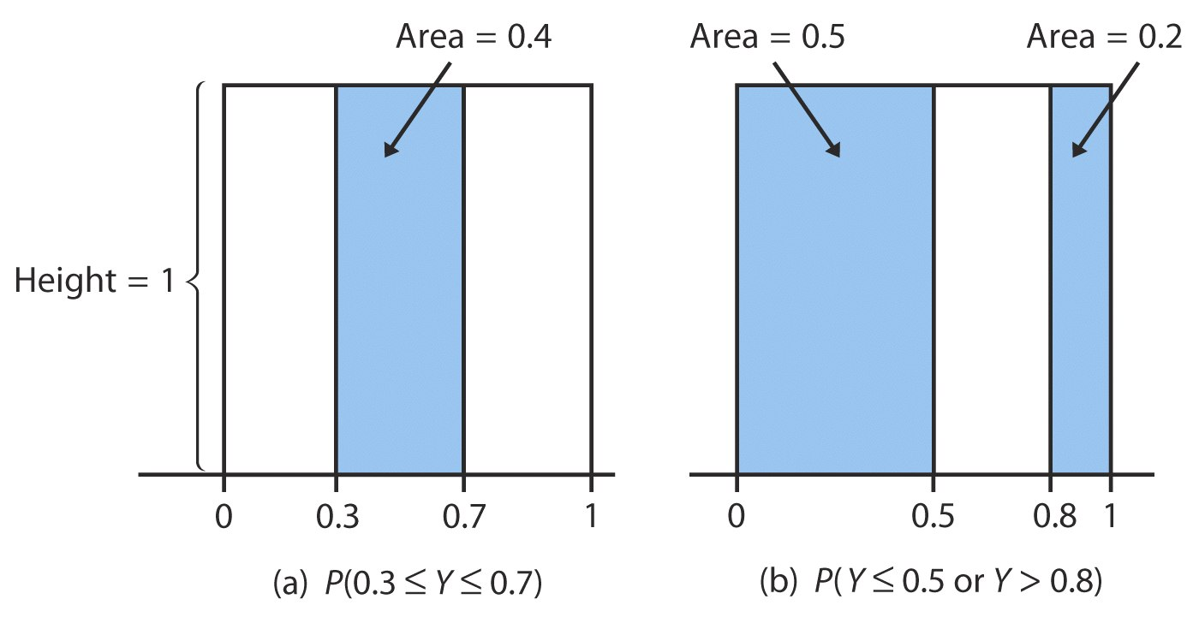

**RANDOM VARIABLES**

A numerical variable that describes the outcomes of a chance process is called a **random variable**.

***Example 11:*** Consider tossing a fair coin 3 times. What is the sample space?

S = {

Define the random variable X to be the number of heads obtained.

|  |  |  |  |  |
| --- | --- | --- | --- | --- |
| X=number of heads |  |  |  |  |
| Outcomes |  |  |  |  |

The **probability distribution** of a random variable gives the values of the random variable and their probabilities.

|  |  |  |  |  |
| --- | --- | --- | --- | --- |
| X=number of heads |  |  |  |  |
| Probability |  |  |  |  |

***Example 12:*** Roll two, fair, six-sided dice (distinguish between them by color). Define the random variable X to be the sum of the dots on the two dice.

S={1,1; 2,1; 3,1; 4,1; … 6,6}



|  |  |  |  |  |  |  |  |  |  |  |  |
| --- | --- | --- | --- | --- | --- | --- | --- | --- | --- | --- | --- |
| X=sum of dots |  |  |  |  |  |  |  |  |  |  |  |
| Probability |  |  |  |  |  |  |  |  |  |  |  |

***Example 13:*** A professor considers the distribution of grades for his economics course. The distribution of grades for 30 students follows:

|  |  |  |  |  |
| --- | --- | --- | --- | --- |
| **A** | **B** | **C** | **D** | **F** |
| 17% | 37% | 26% | 12% | 8% |

Assign student grades on a four-point scale to a random variable X.

|  |  |  |  |  |  |
| --- | --- | --- | --- | --- | --- |
| X=points |  |  |  |  |  |
| Probability |  |  |  |  |  |

1. Is the random variable discrete or continuous? Why?
2. Write the event “at least a C” in terms of X. What is the probability of this event?
3. Describe the event X ≤ 1 in words. What is the probability? What is the probability that X < 1?